Commands

1: pwd - present working directory

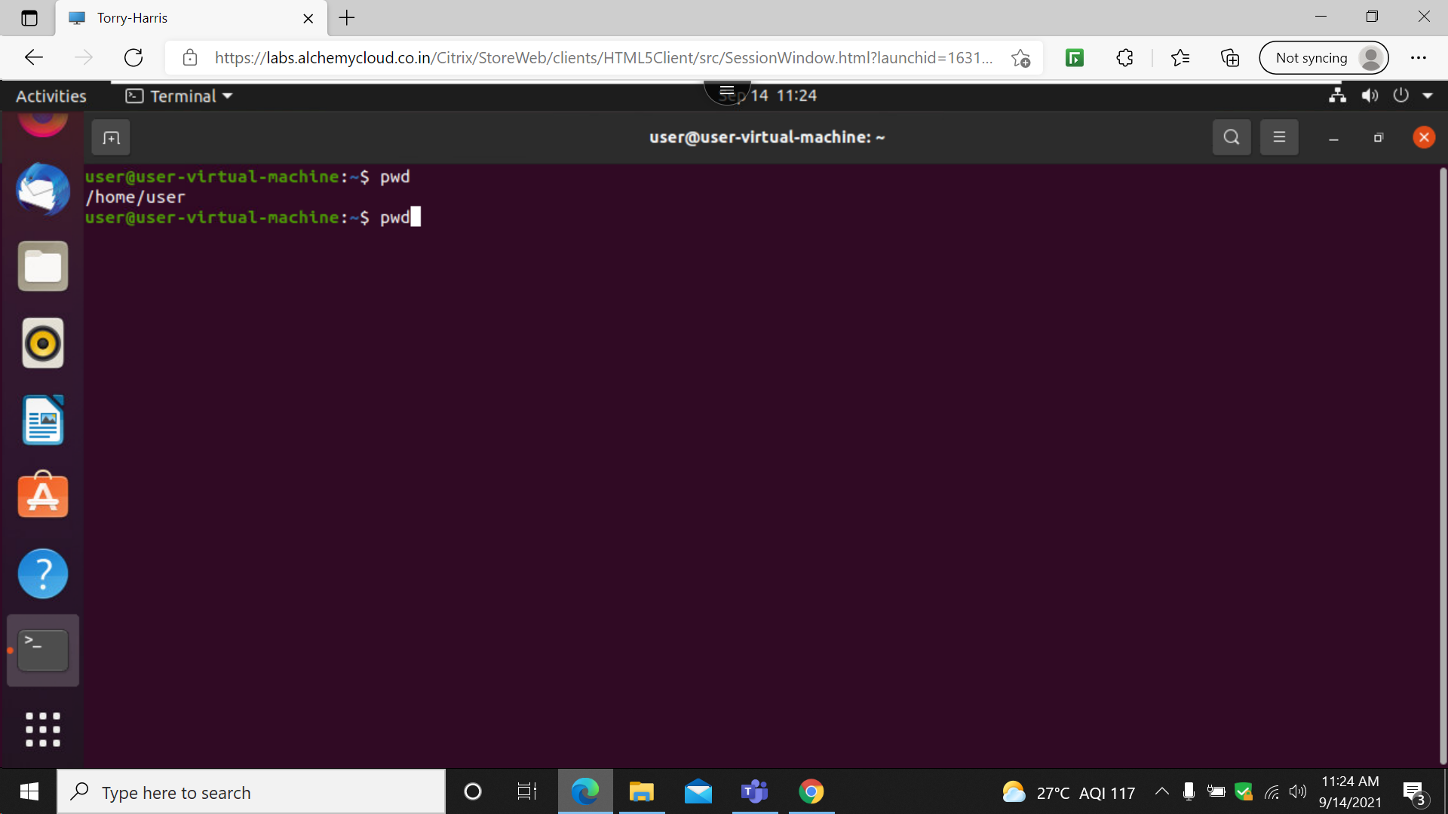

The pwd command is used to display the present working directory .

2: clear

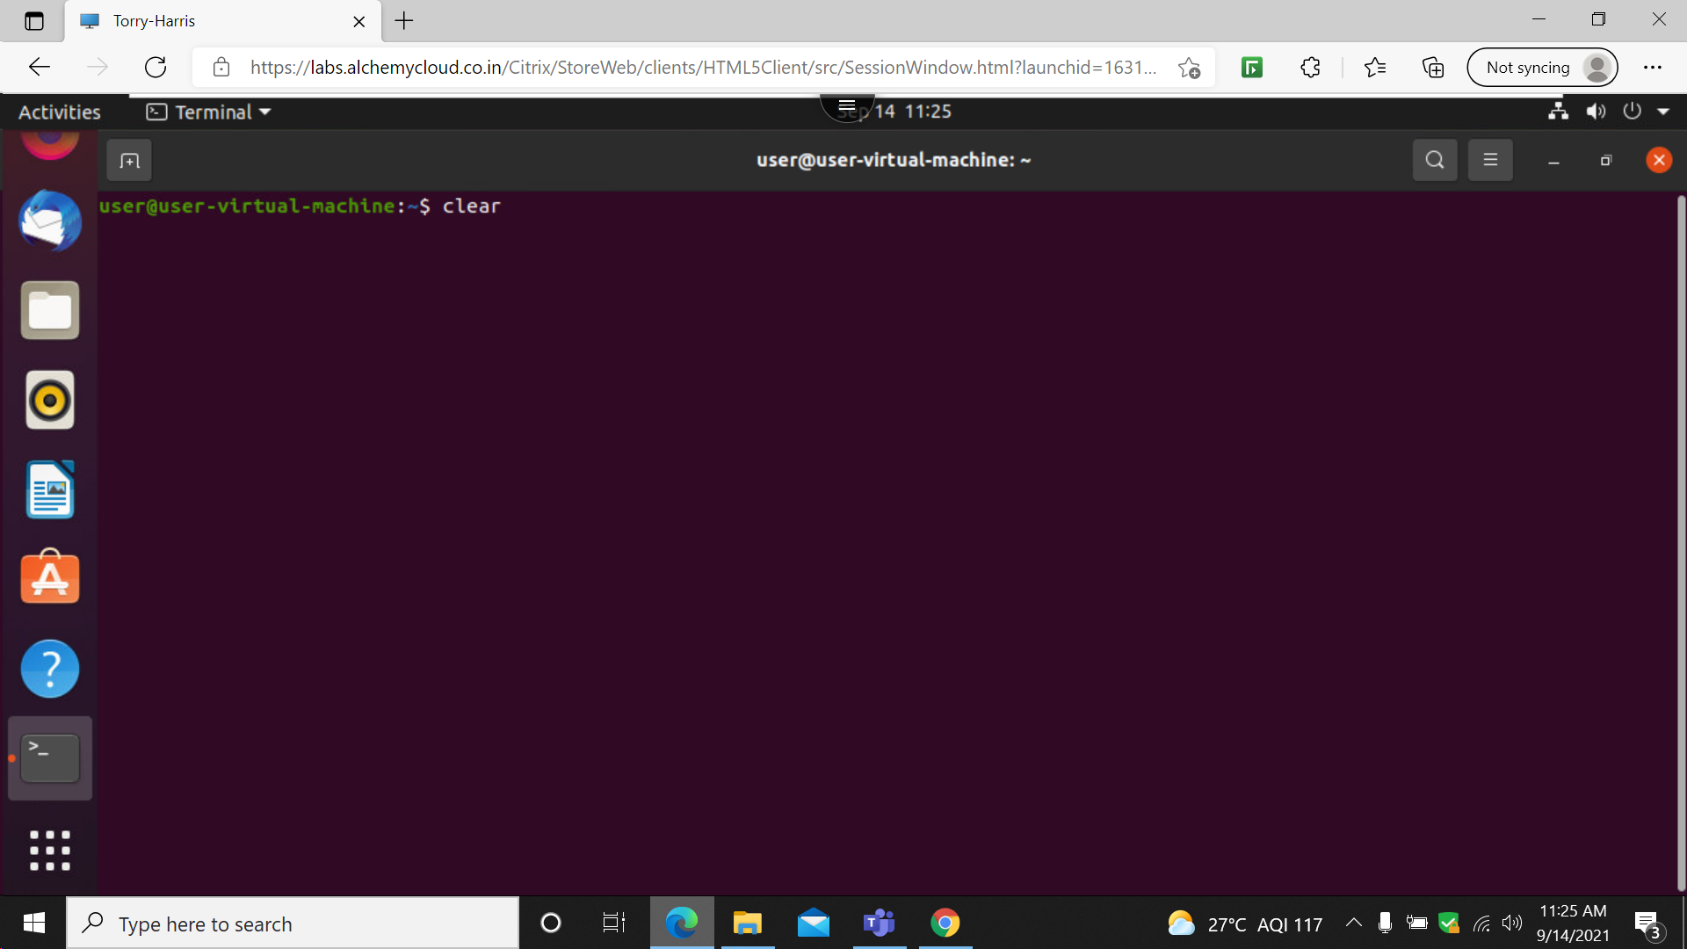

Clear command is used to clear the screen

3: ls

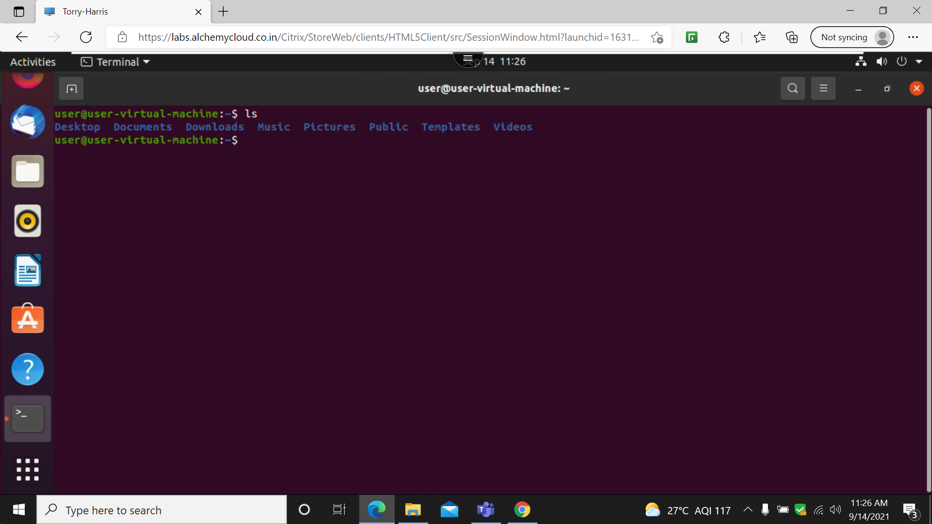

The ls command is used to list all the directory present in the working directory

4: man ls : manual

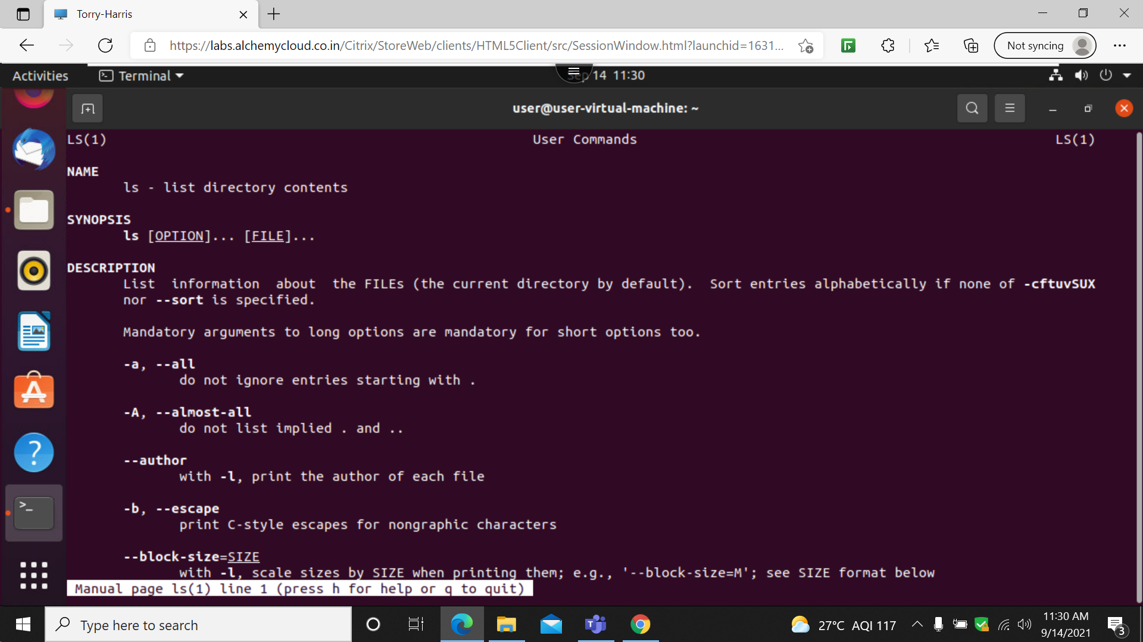

The man –ls command is used to display the manual of ls

5:ls-a

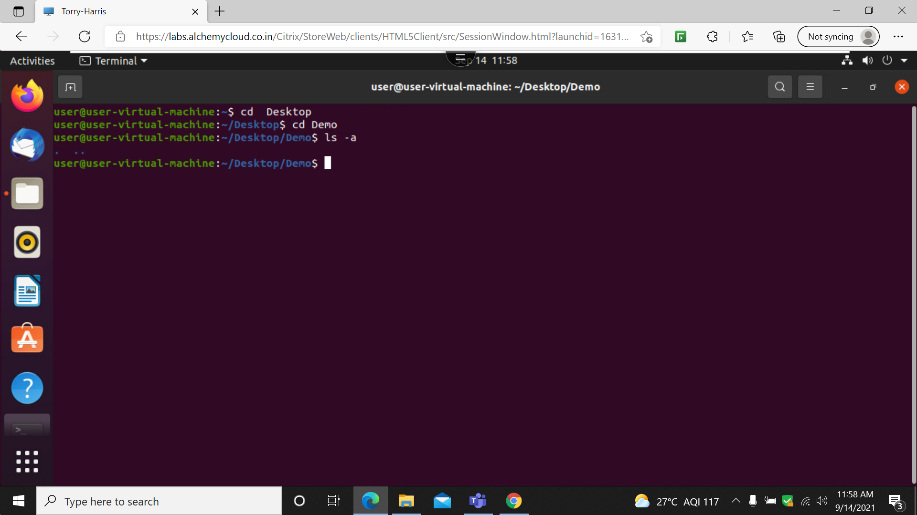

The ls- a command is used to display all the folders with hidden folders

6: ls –f

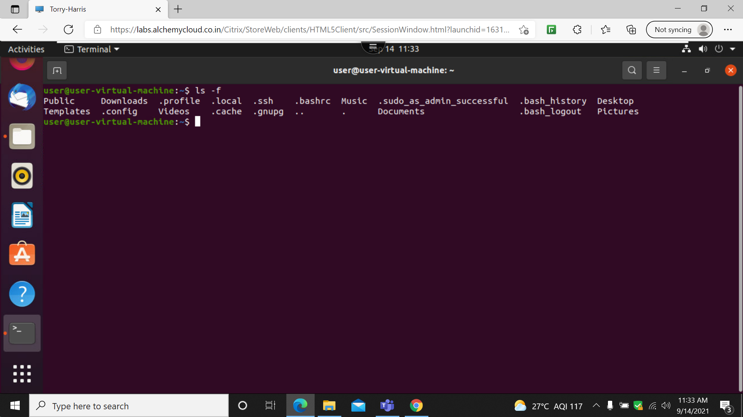

The ls-f command is used to display all the folders without any format

7: echo

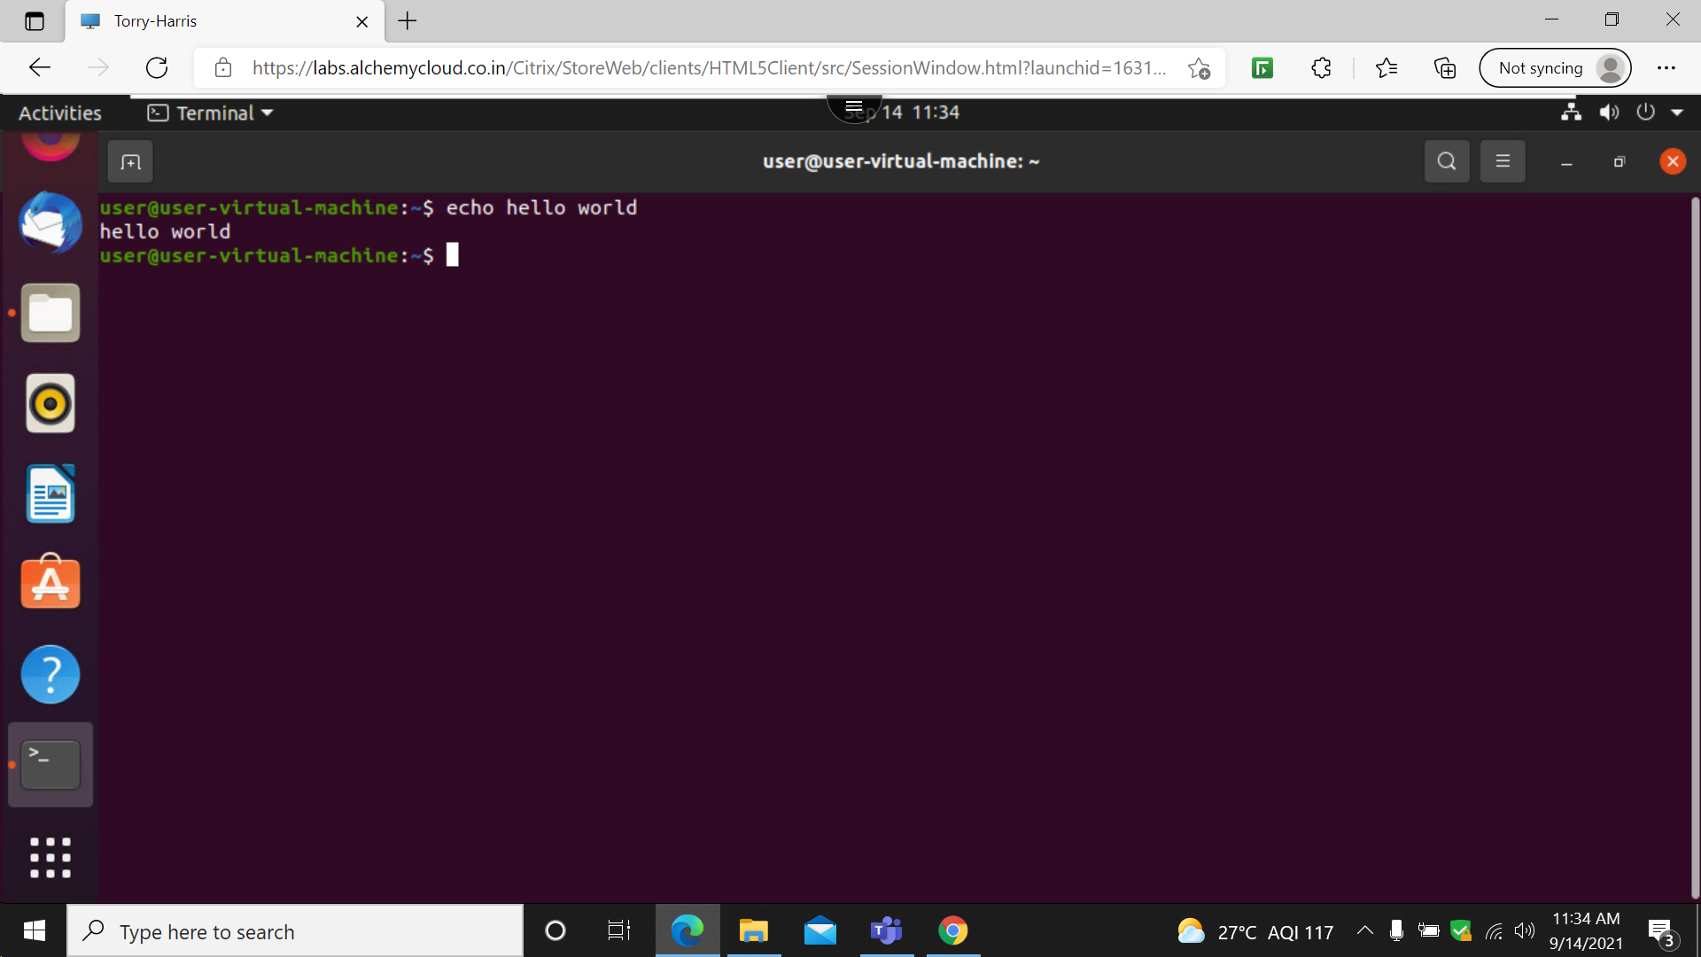

The echo command is used to print command

8: cd /

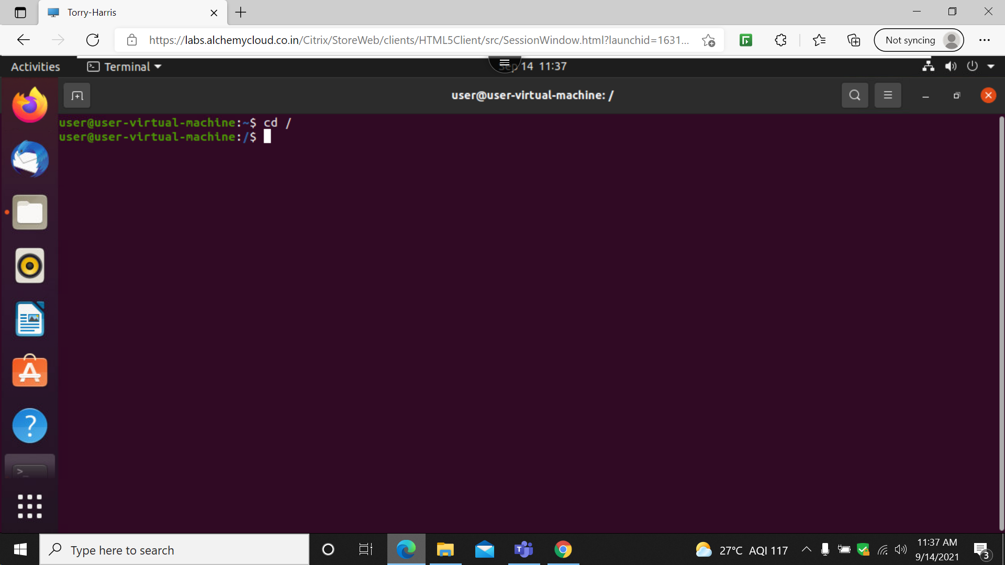

The cd / command is used to change the directory to home directory

9 : cd ~

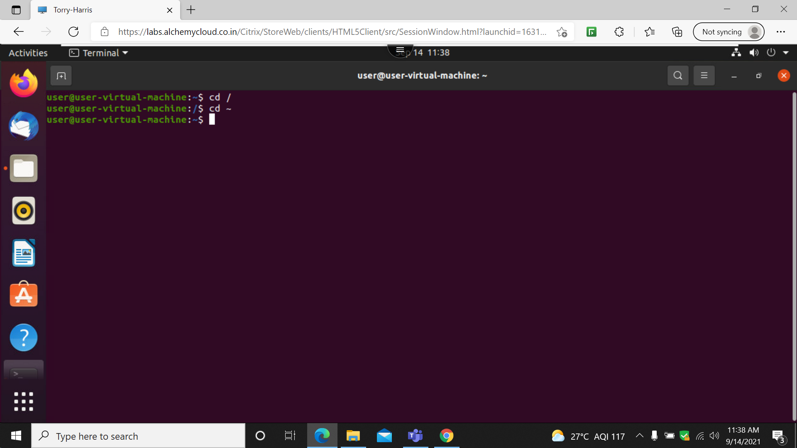

The cd ~ is used to change the directory to root directory

10 : ls –A

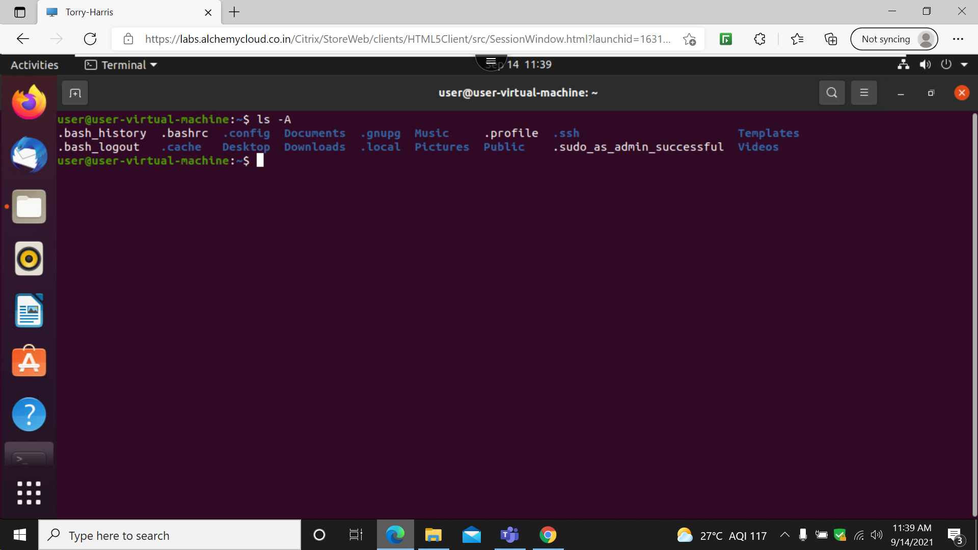

The ls-A command is used to ignore the hidden files and display the other files .

11 : ls –l

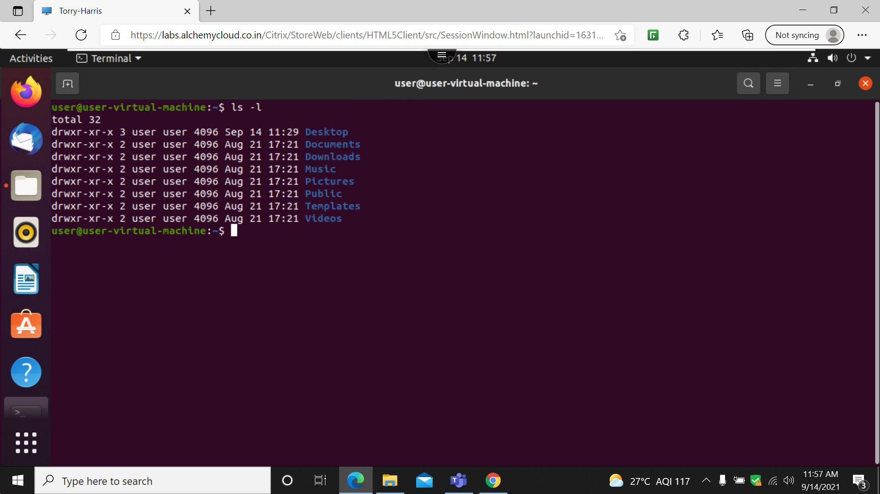

The ls-l command is descriptive list all the folder present.

12 : cd Desktop

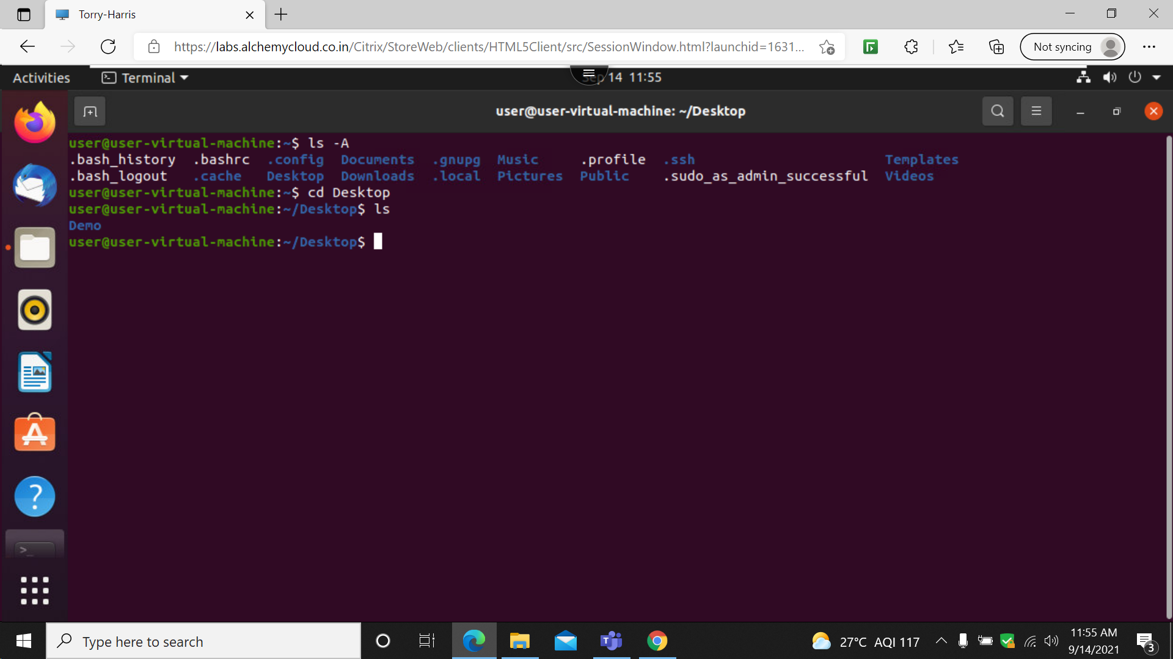

The cd desktop is used to change the working directory to desktop

13: cd ..

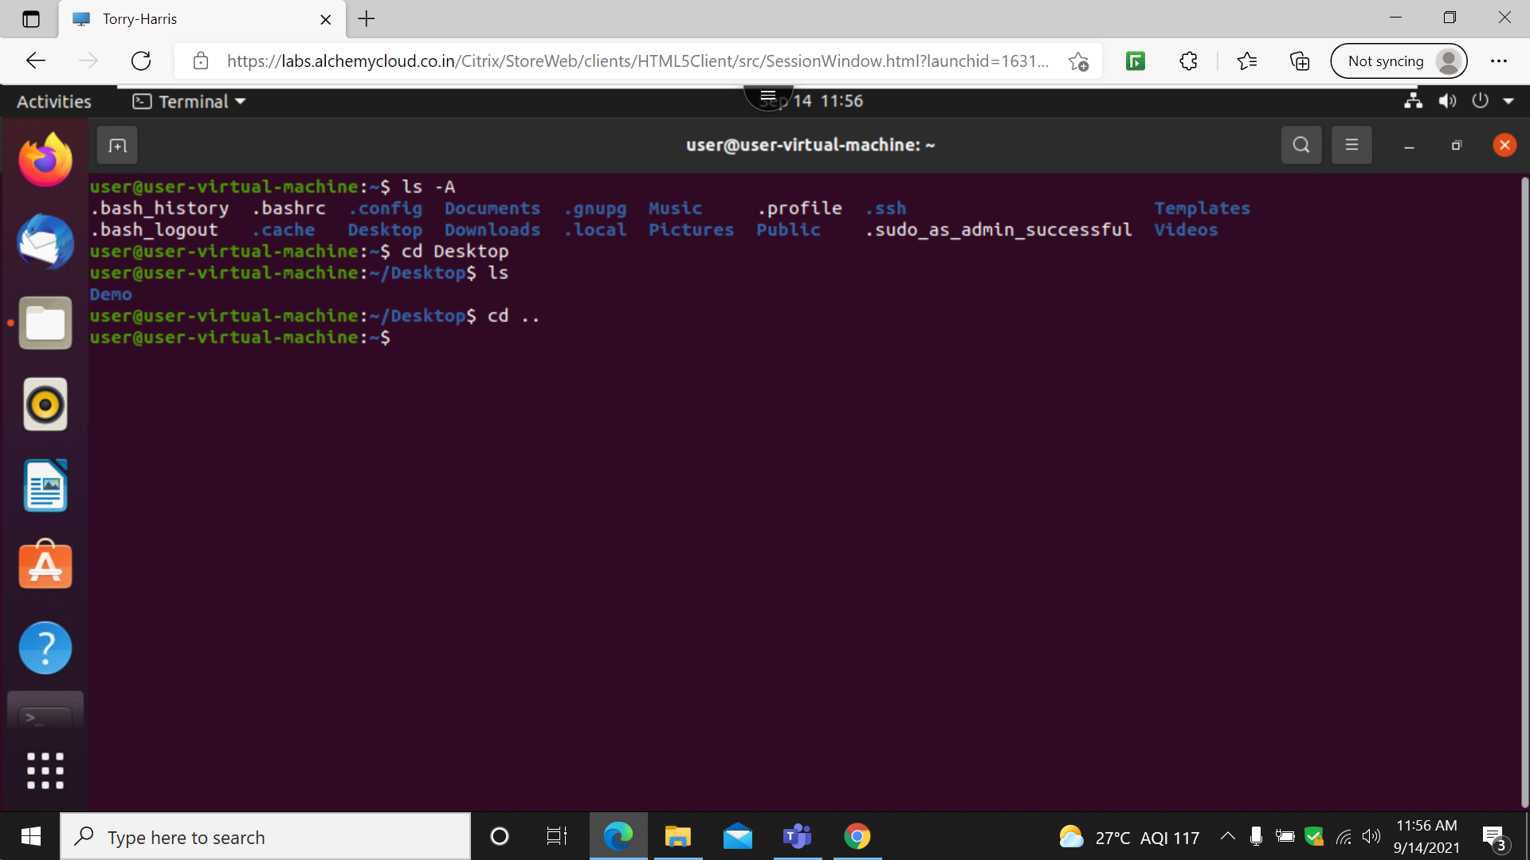

The cd .. command is used to go back one step

14: mv

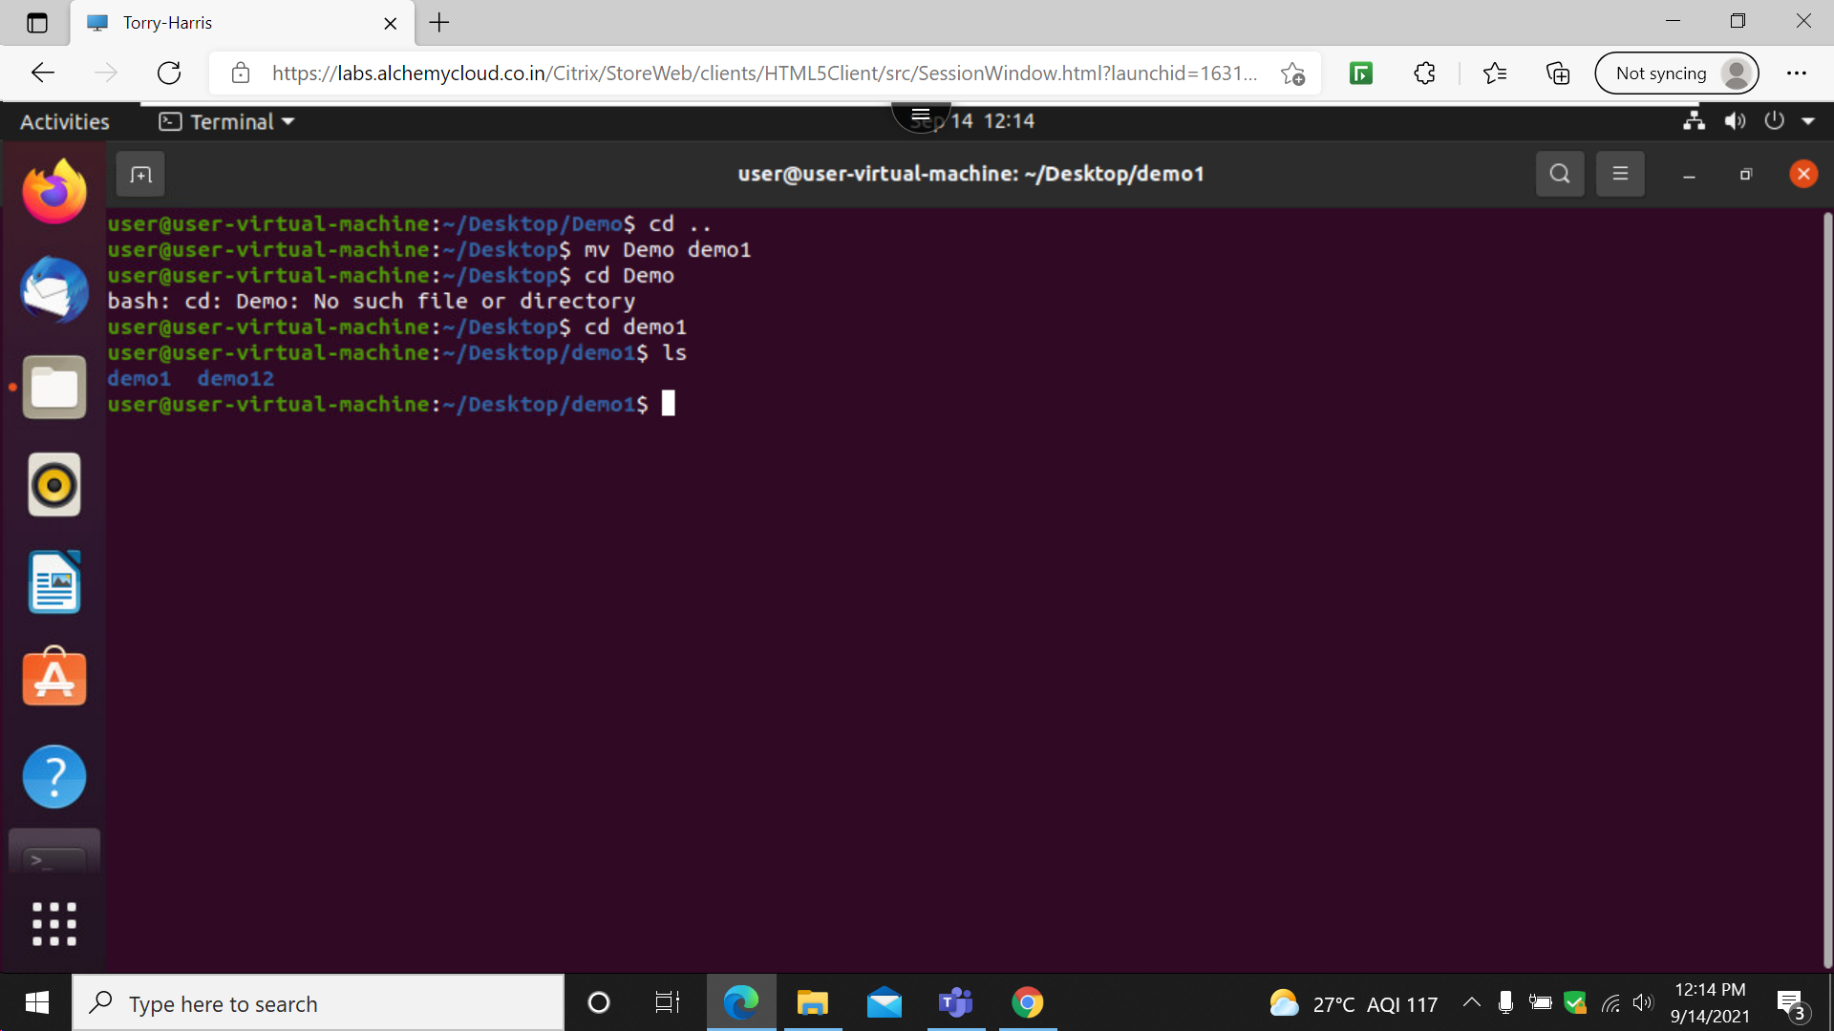

The mv command is used to renaming the file

15: who

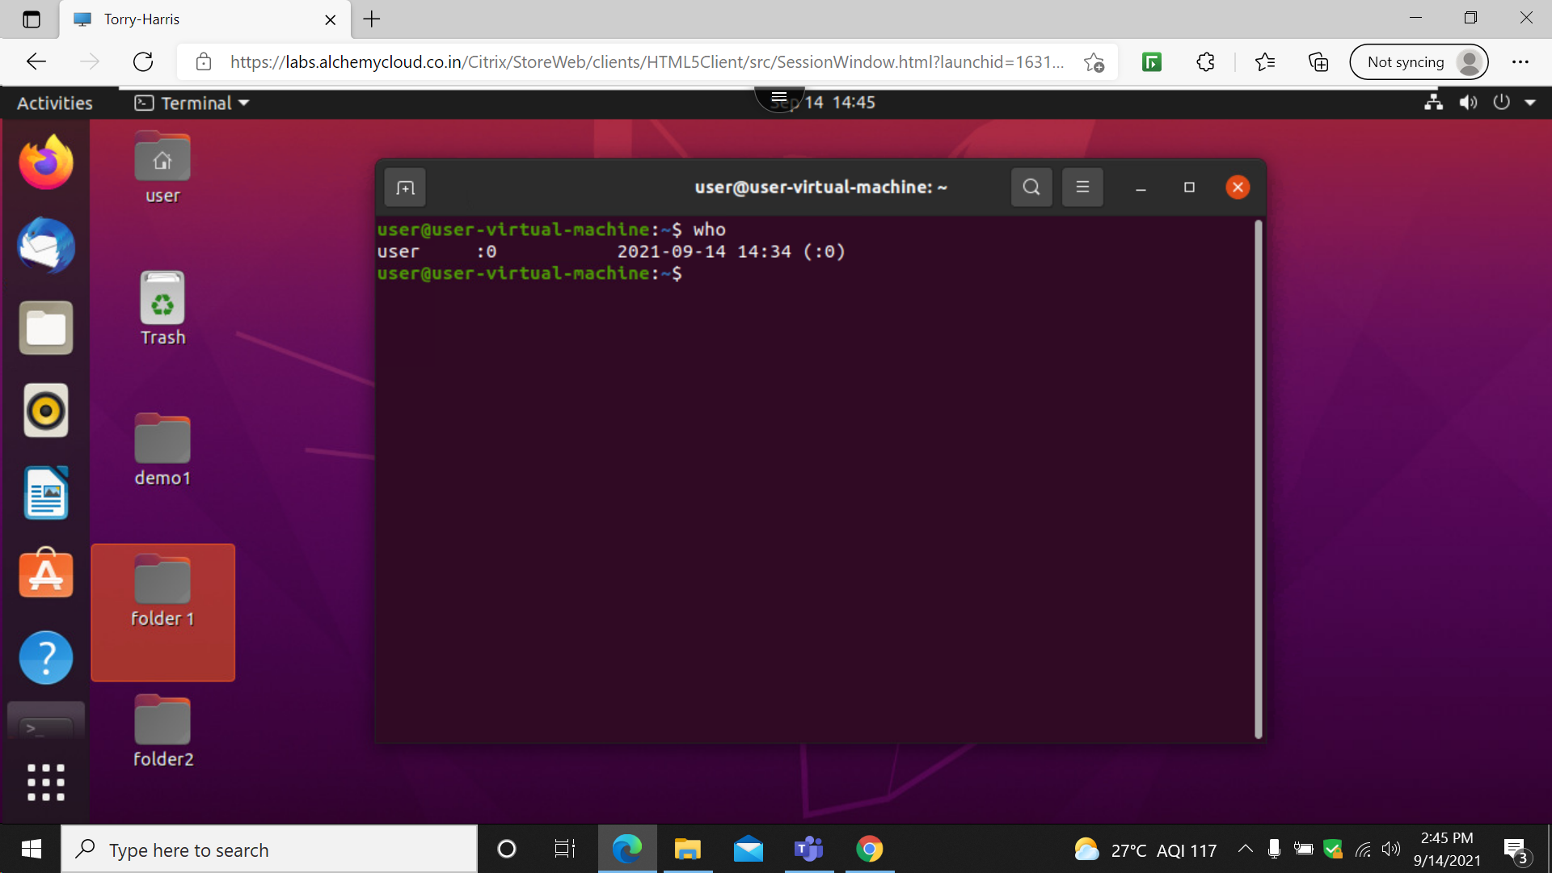

The who is used to display current user & session details

16 : desktop ls demo

17: date–date

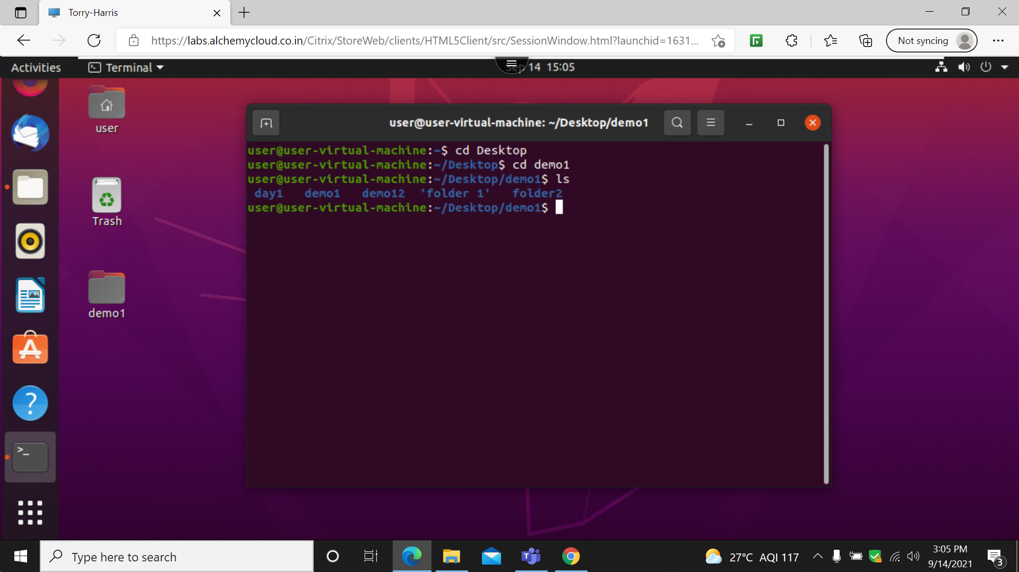

The date command is used display current date & time

18: calendar – cal

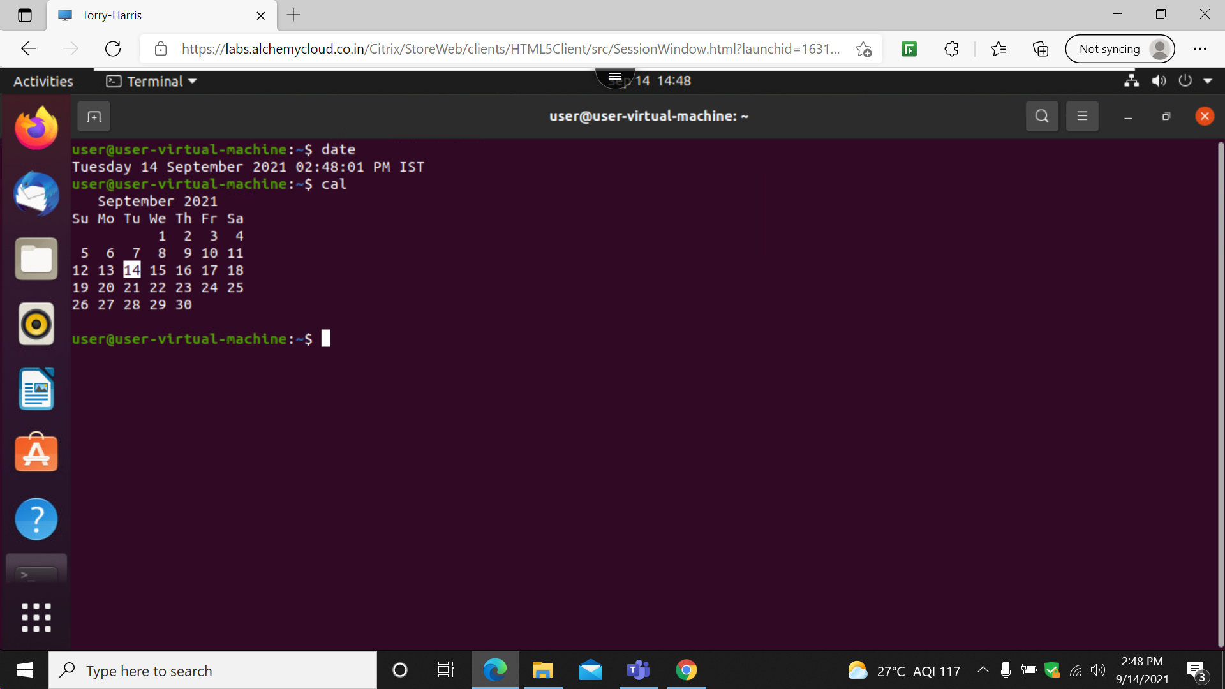

The cal command is used to display the current calender details

19: rm –remove

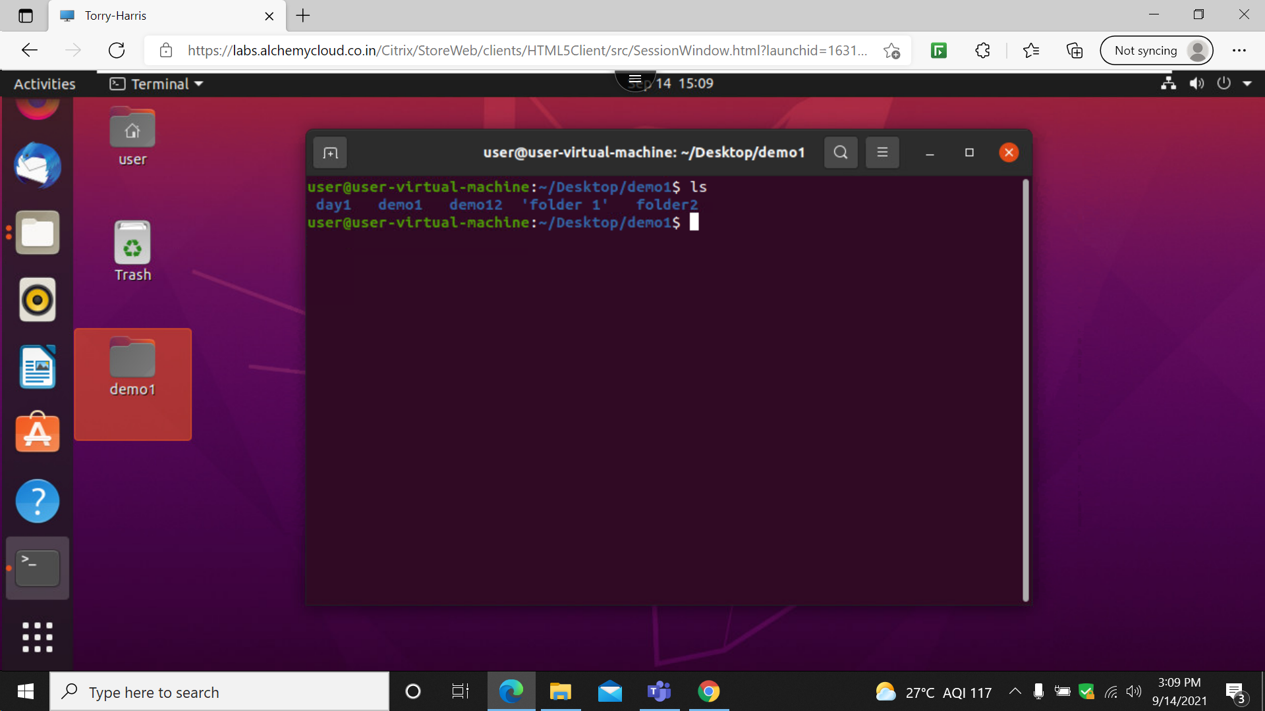

The rm command is used to remove a text file

20 : cp –copy

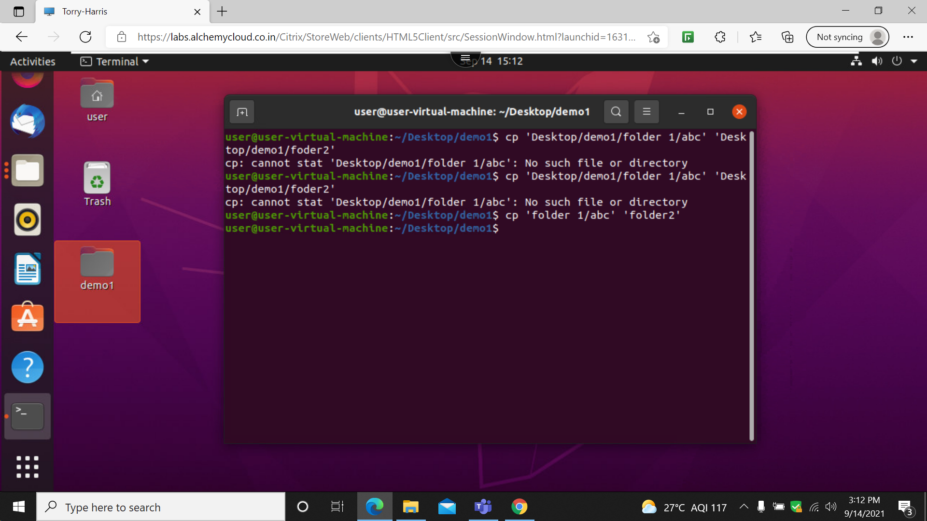

The cp command is used to copy the contents of 1file to other file

21: mv-move

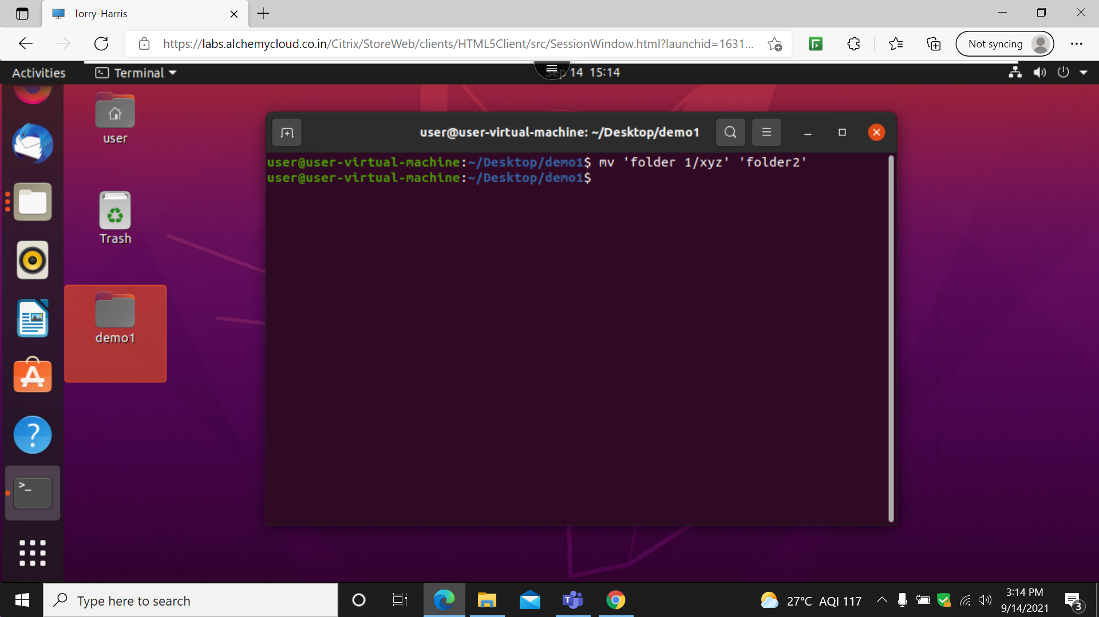

The mv command is used moving the file

22: passwd

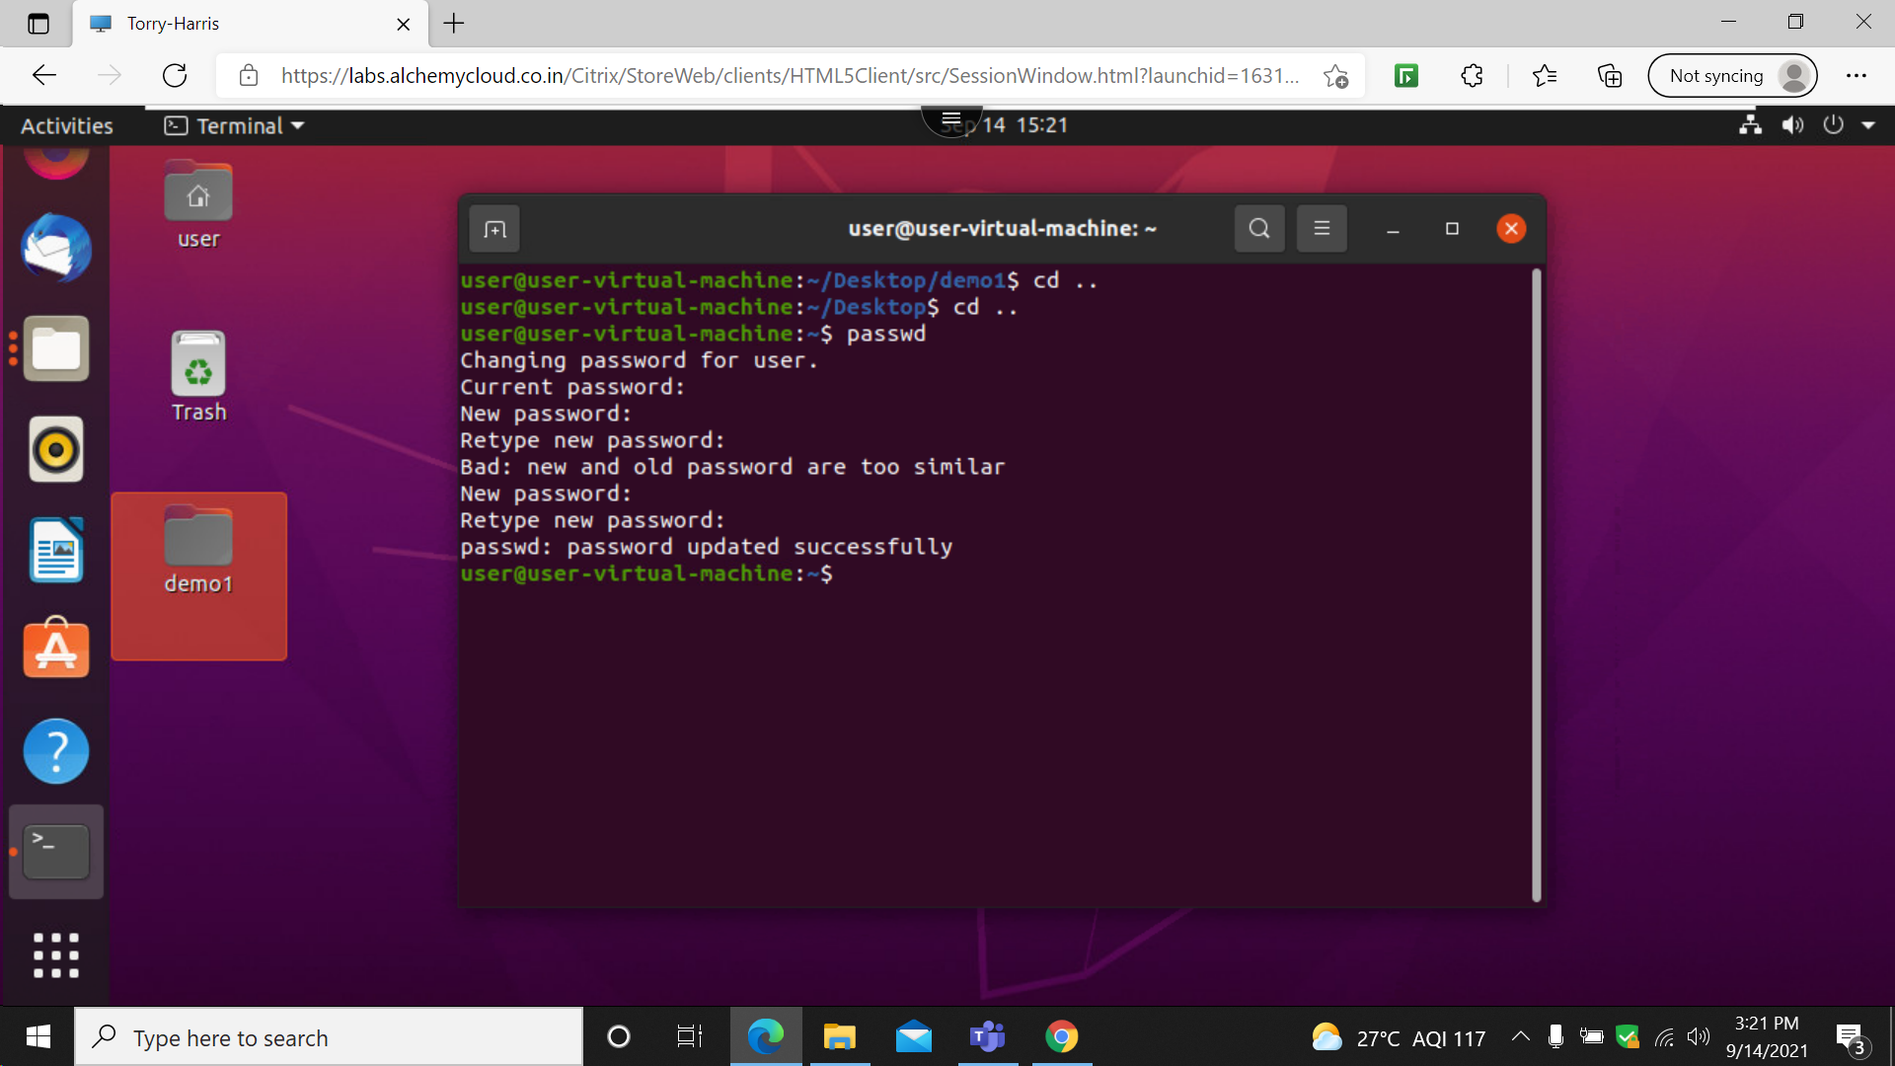

This command is used to display the current password for the user & allow to change it

23: mkdir

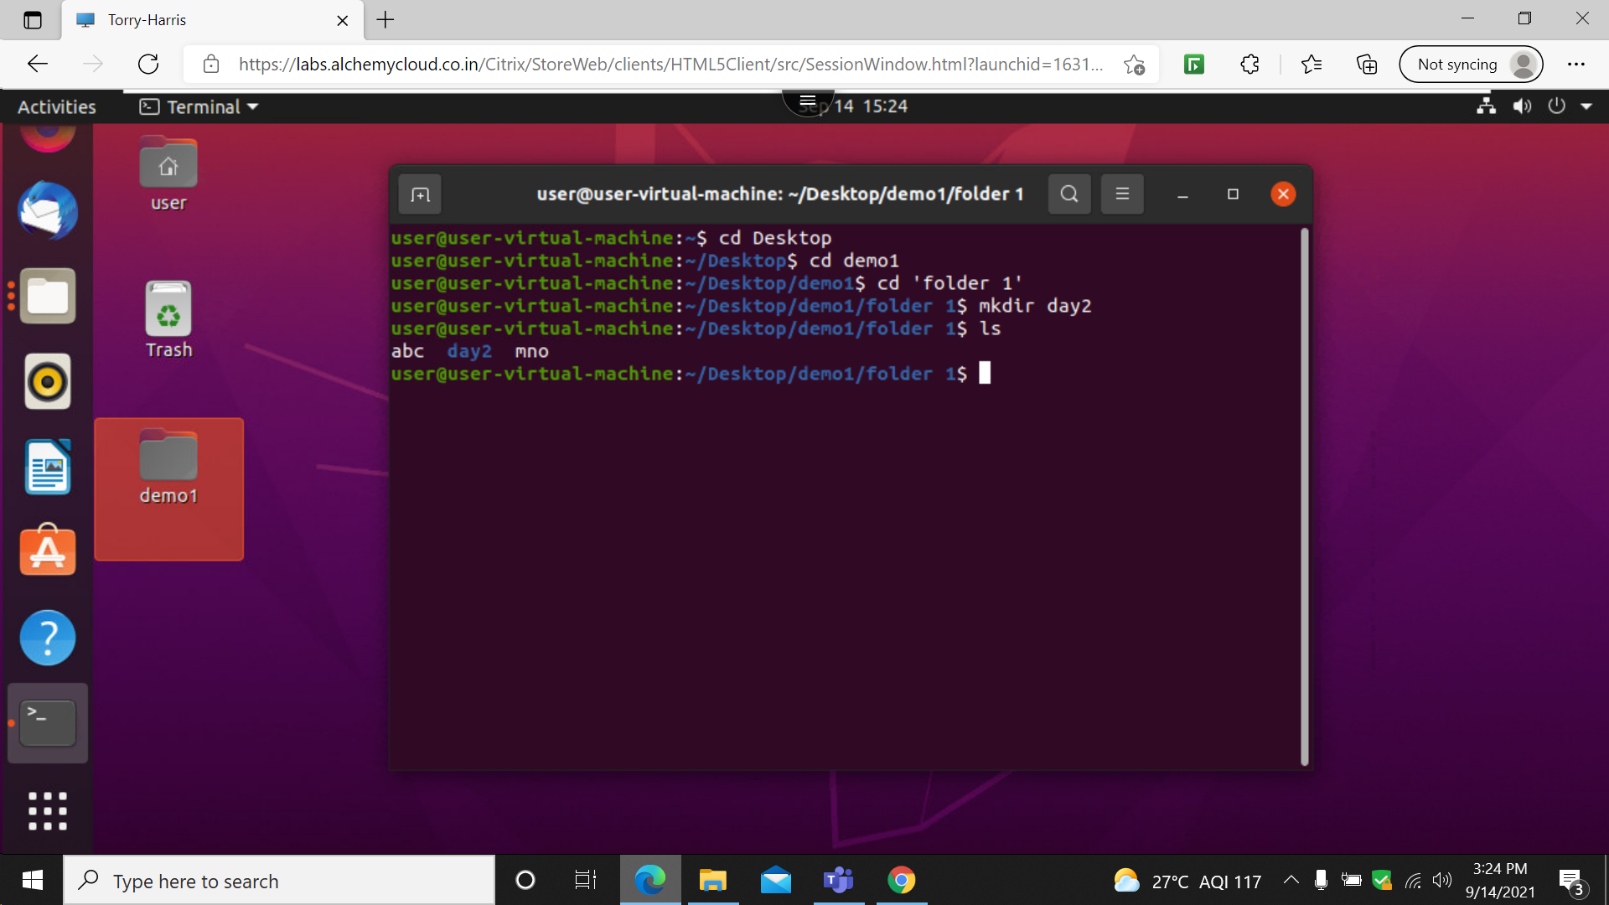

This command is used to create a new directory

24: rmdir

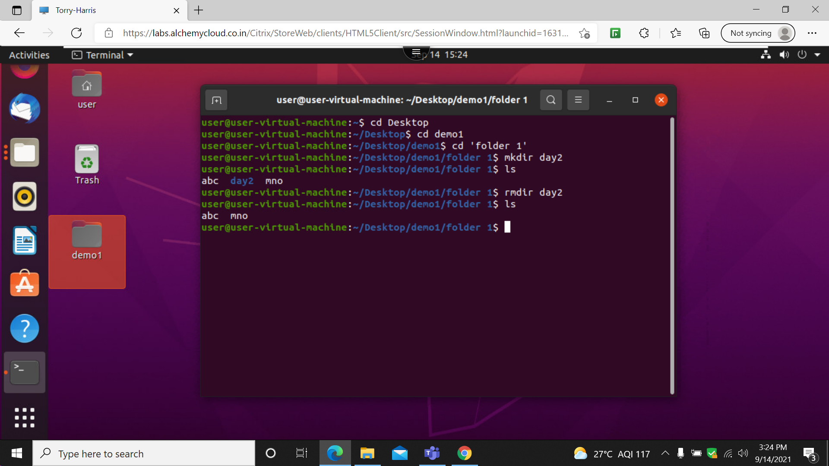

This command is used to remove the directory

25: ls-lr

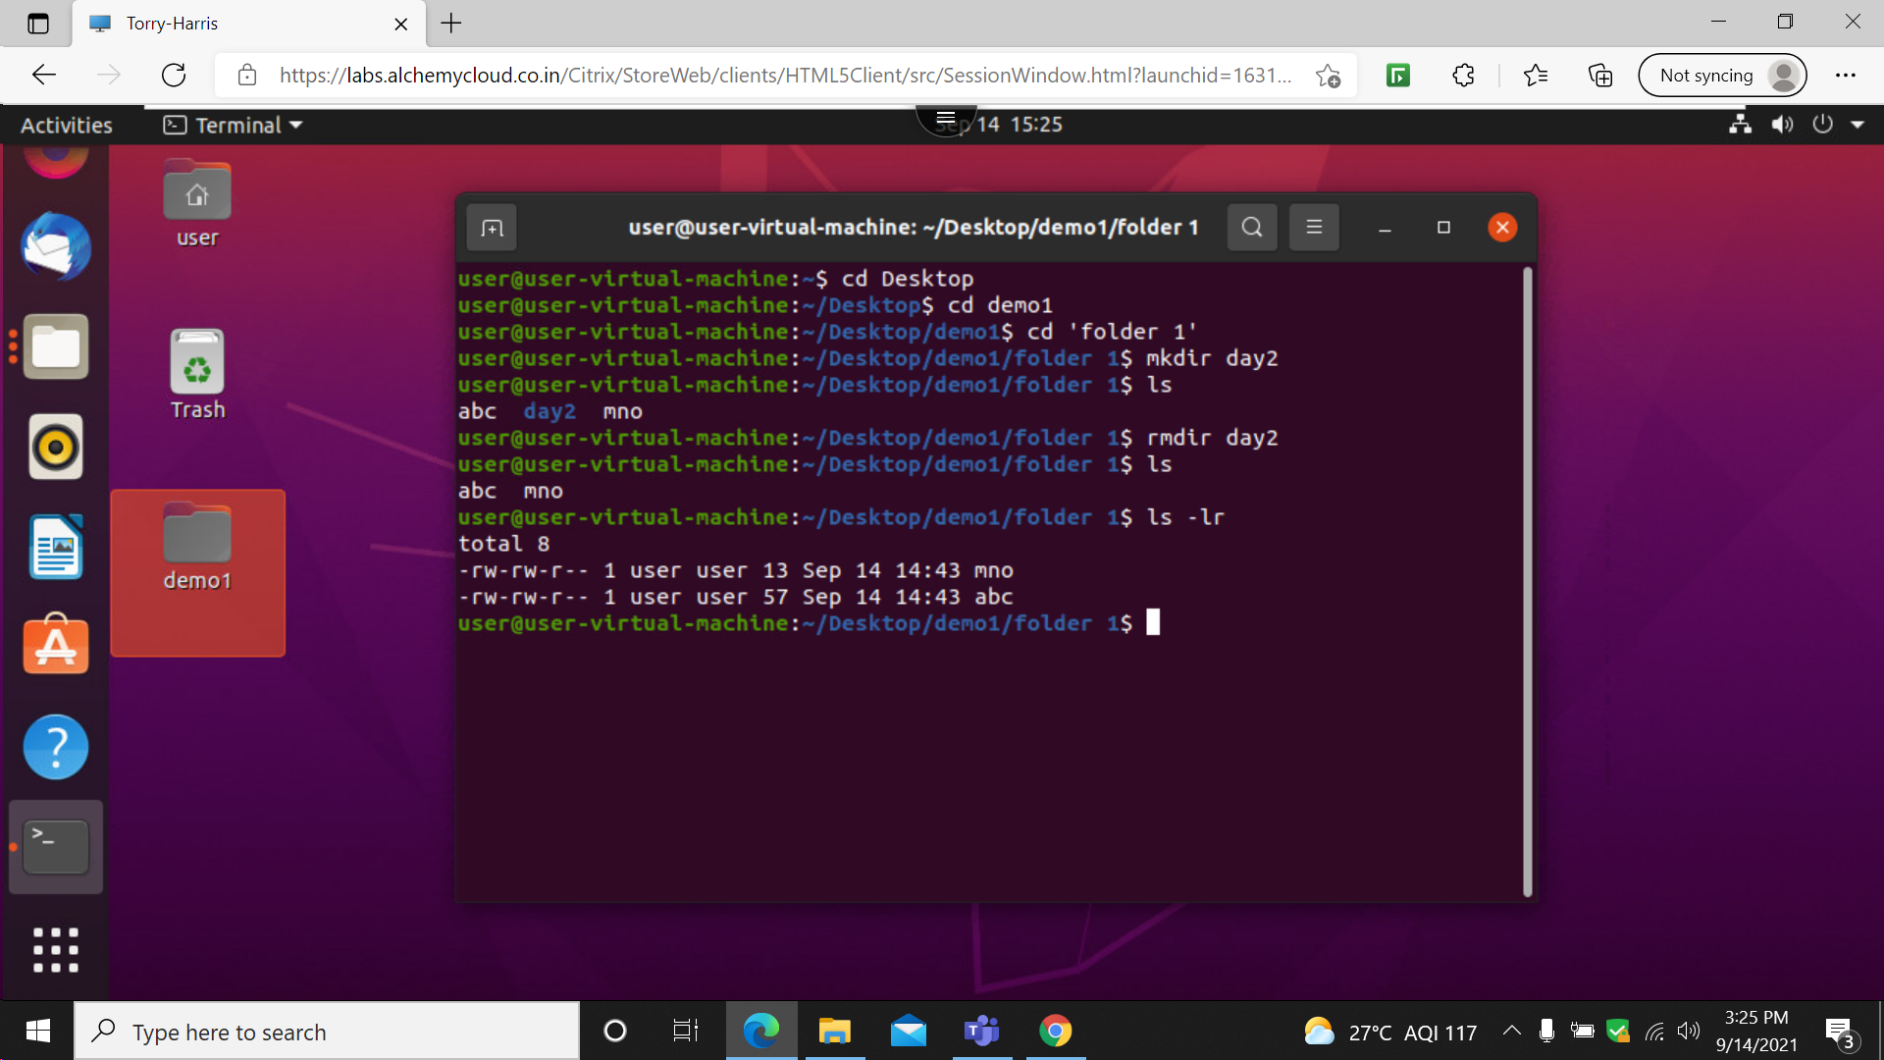

This command is used to display the folder in an recursive manner

26: ls-a

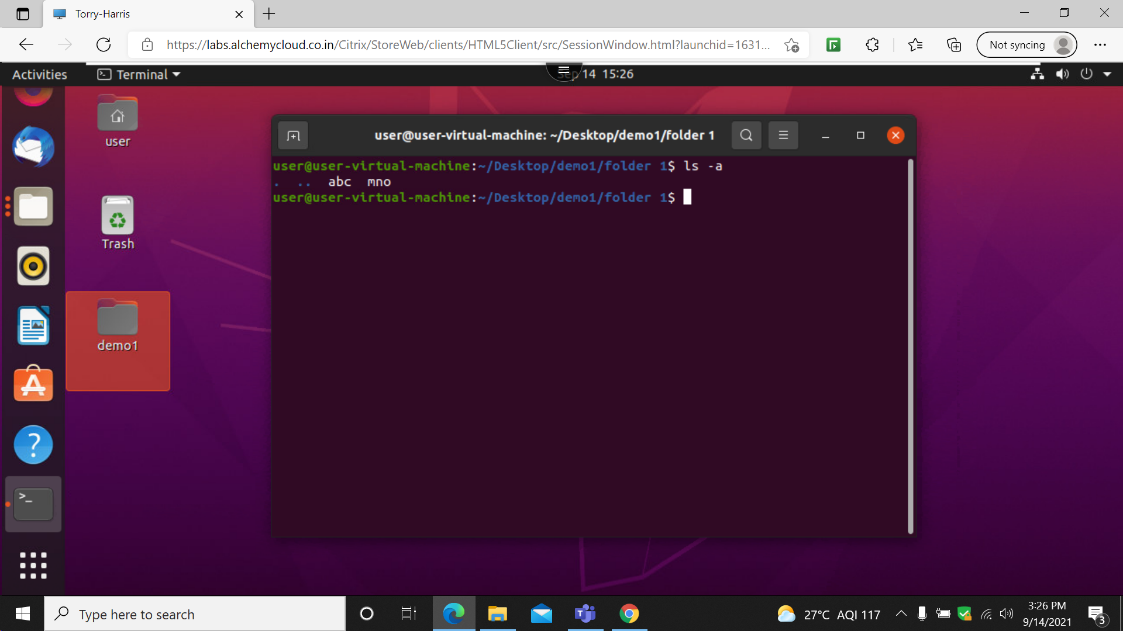

This command is used to list the folder along with the hidden folder

27: ls-l-a

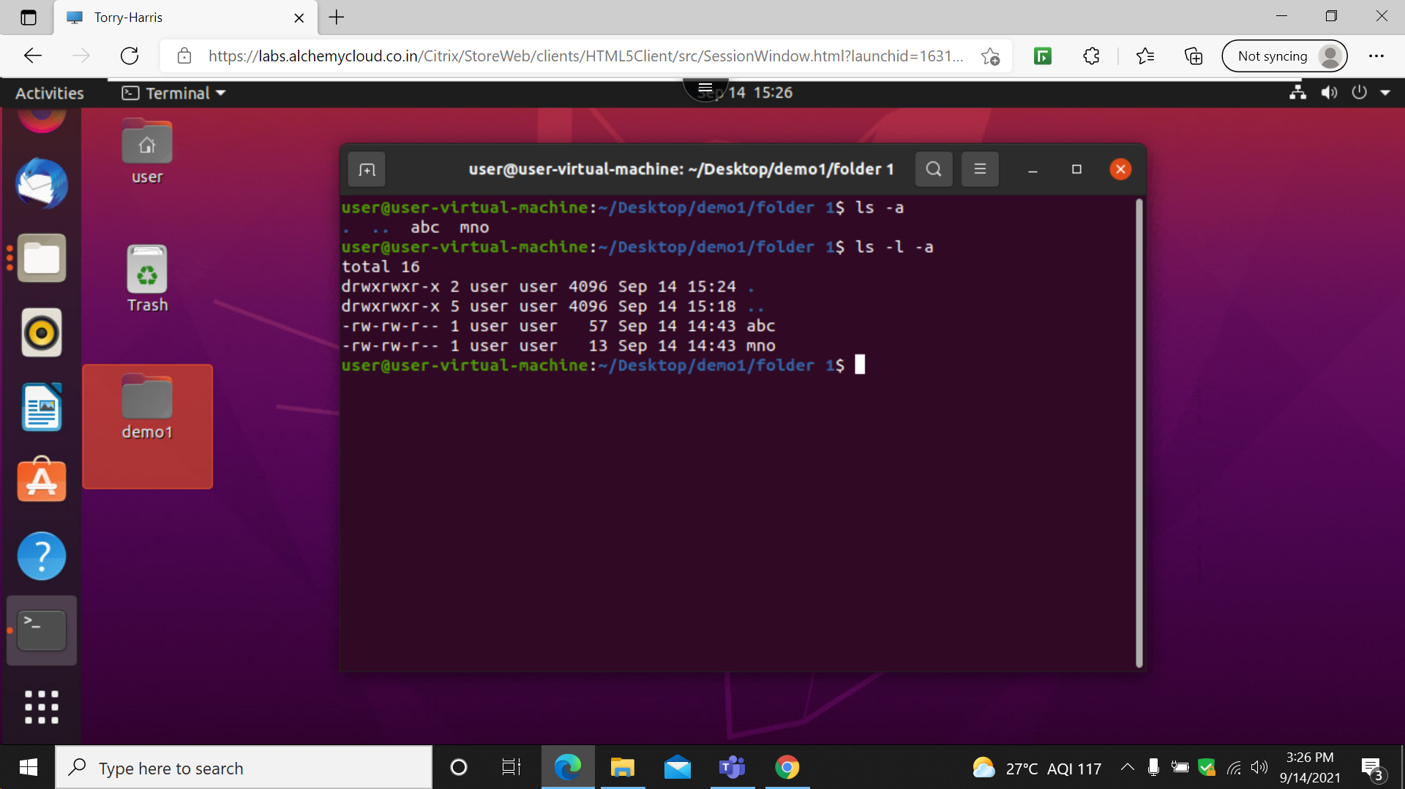

This command is used to list the folder along with the hidden folder

28: ls-l-a-r

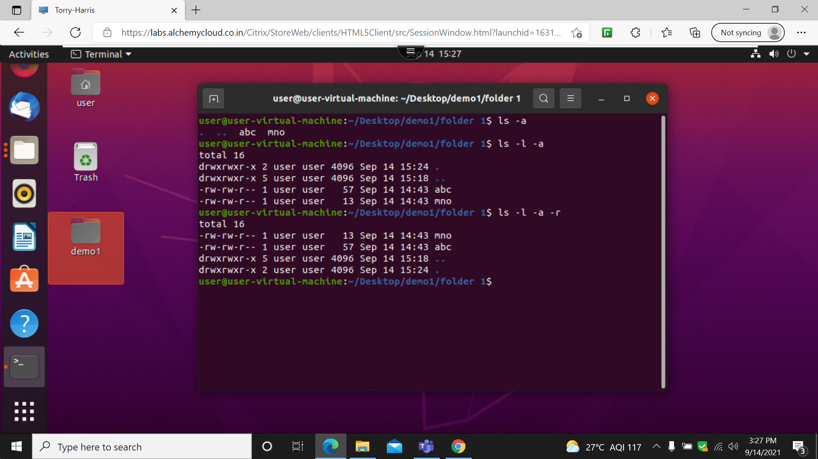

This command is used to list the folder along with the hidden folder in a recursive manner .

29: tree

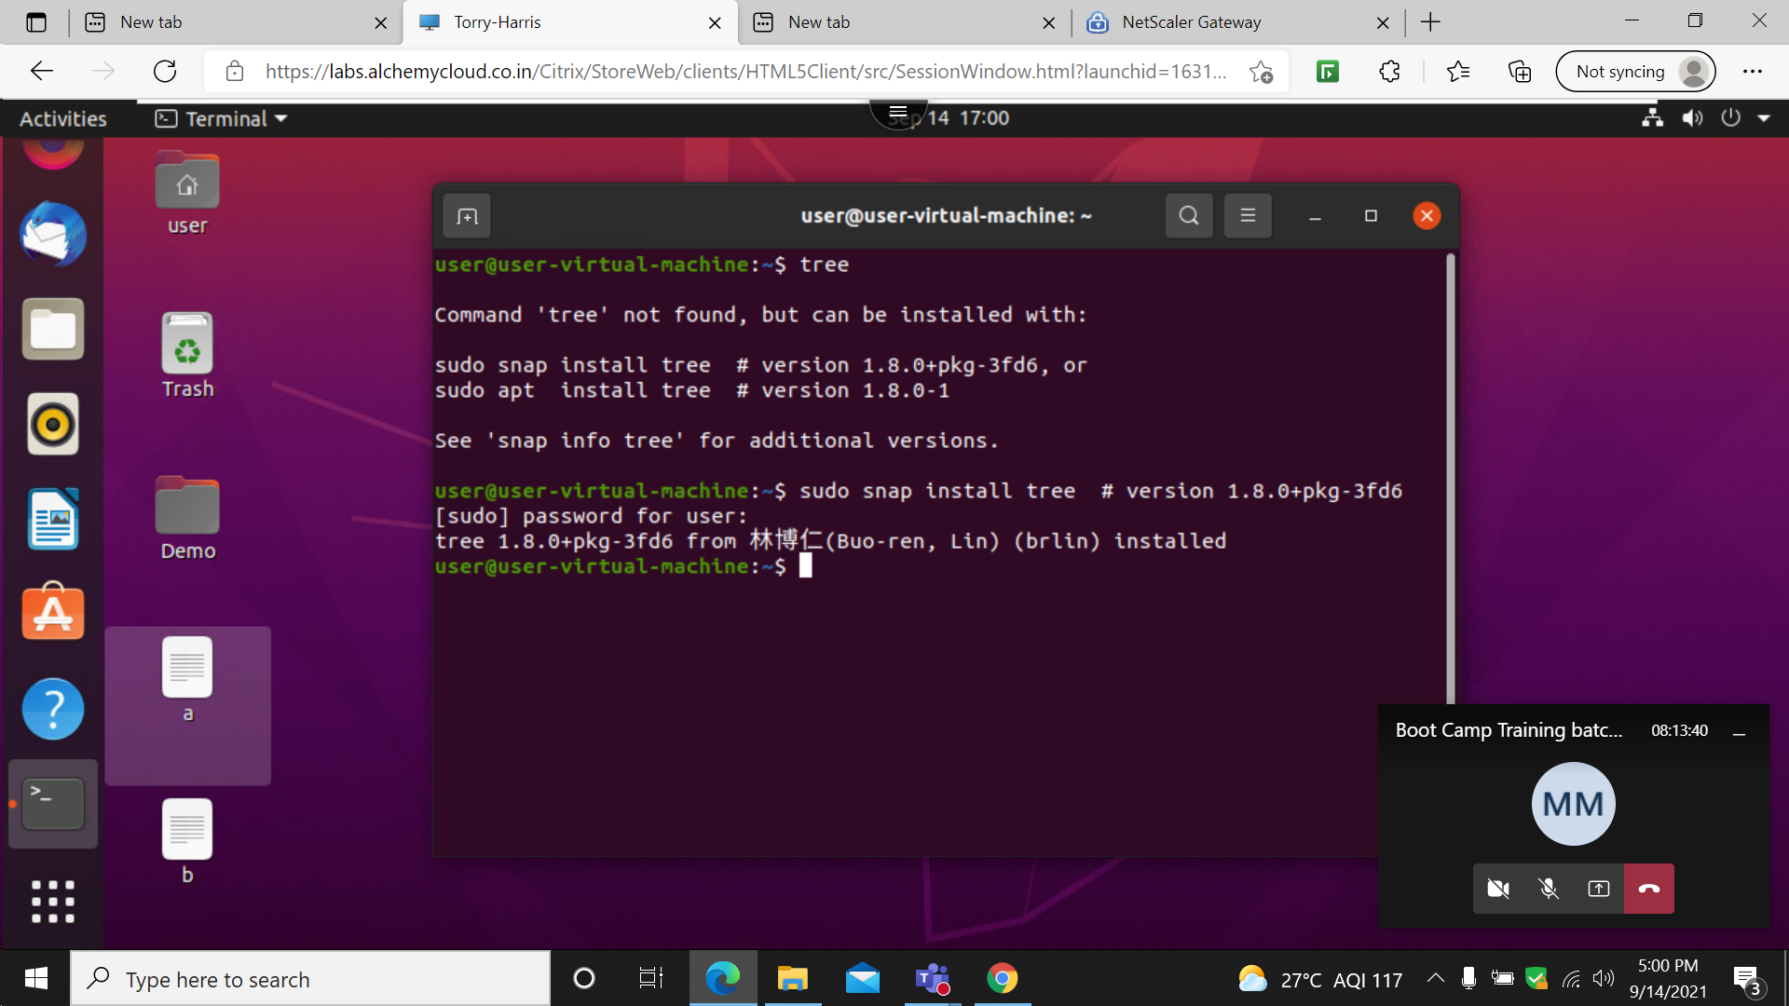

30: desktop$ tree

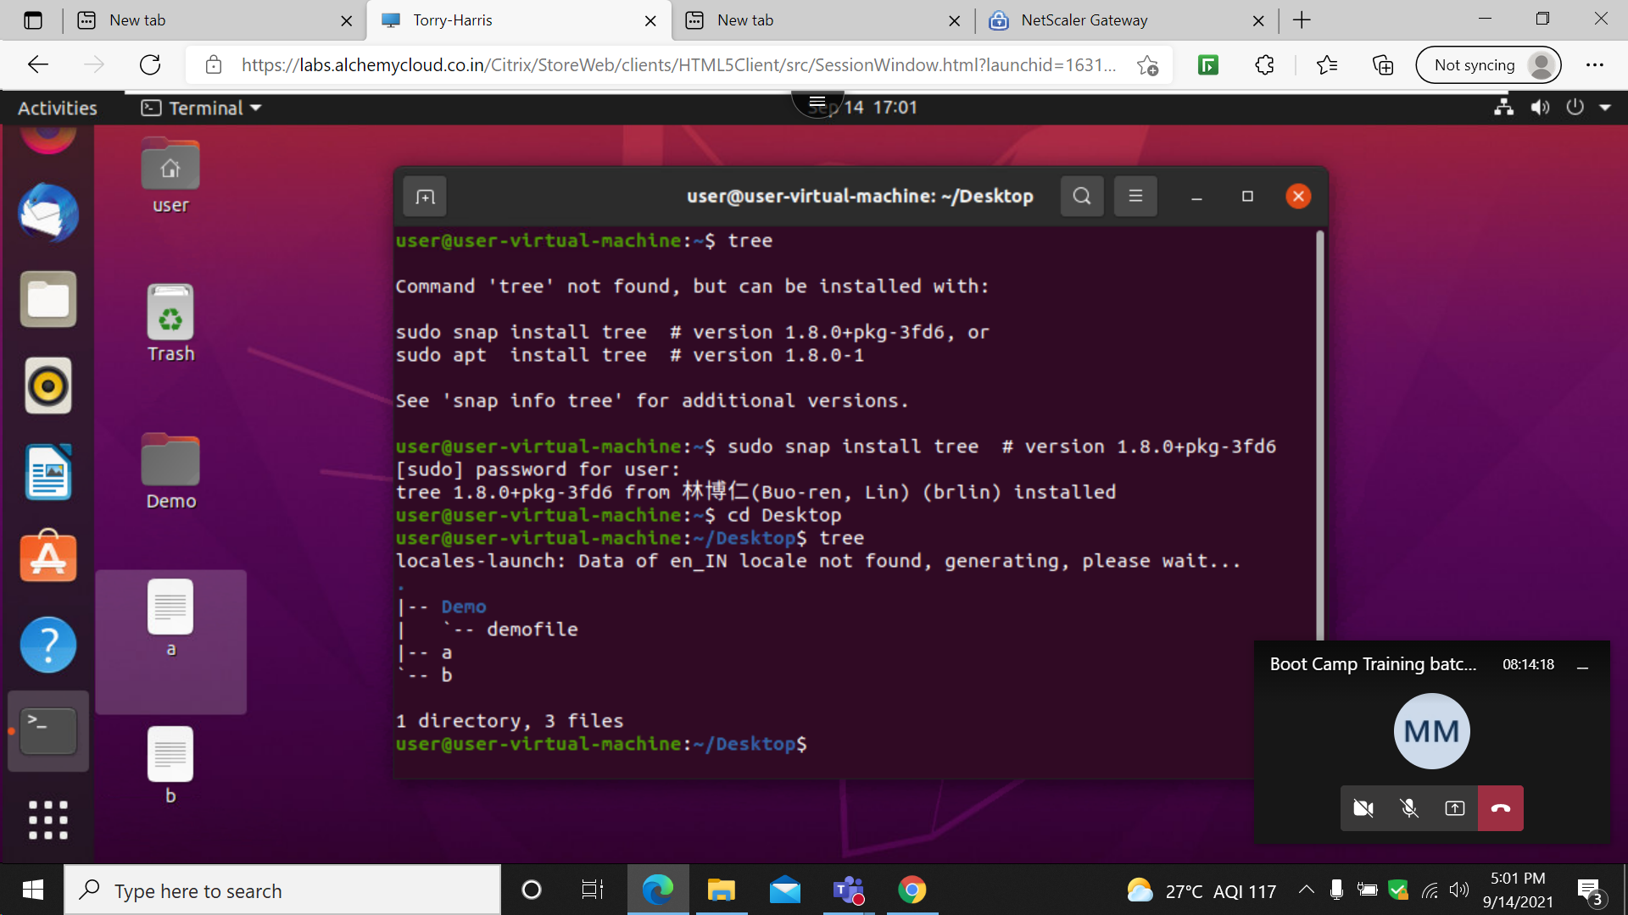

31: desktop$ tree –d

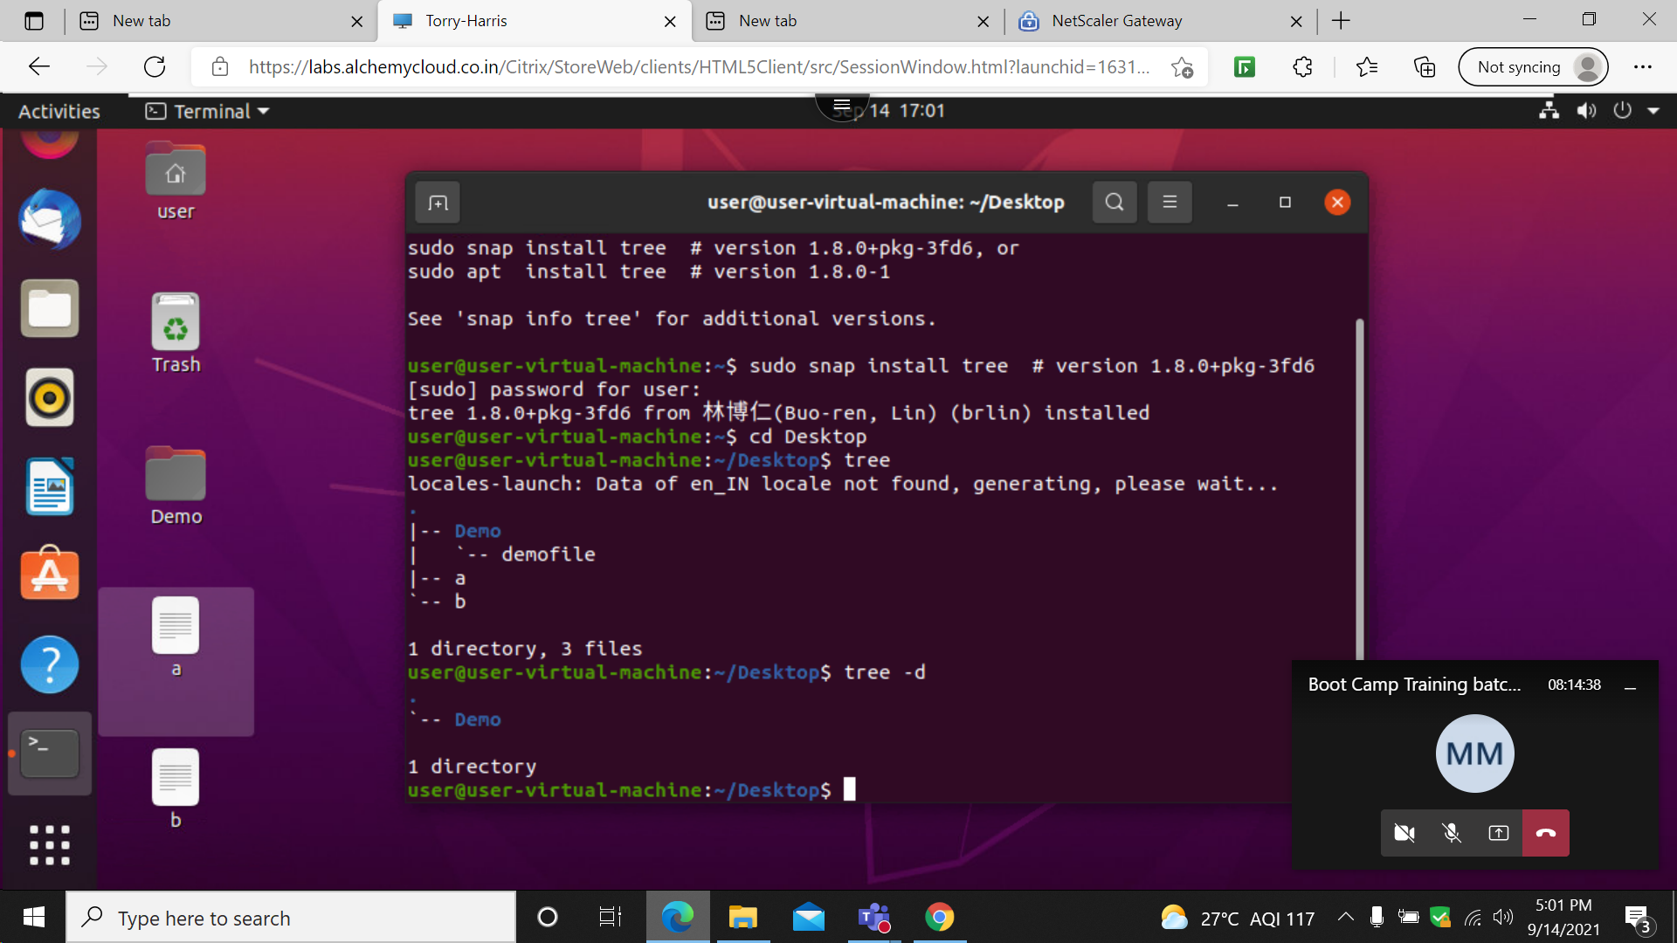

32: desktop$ tree –c

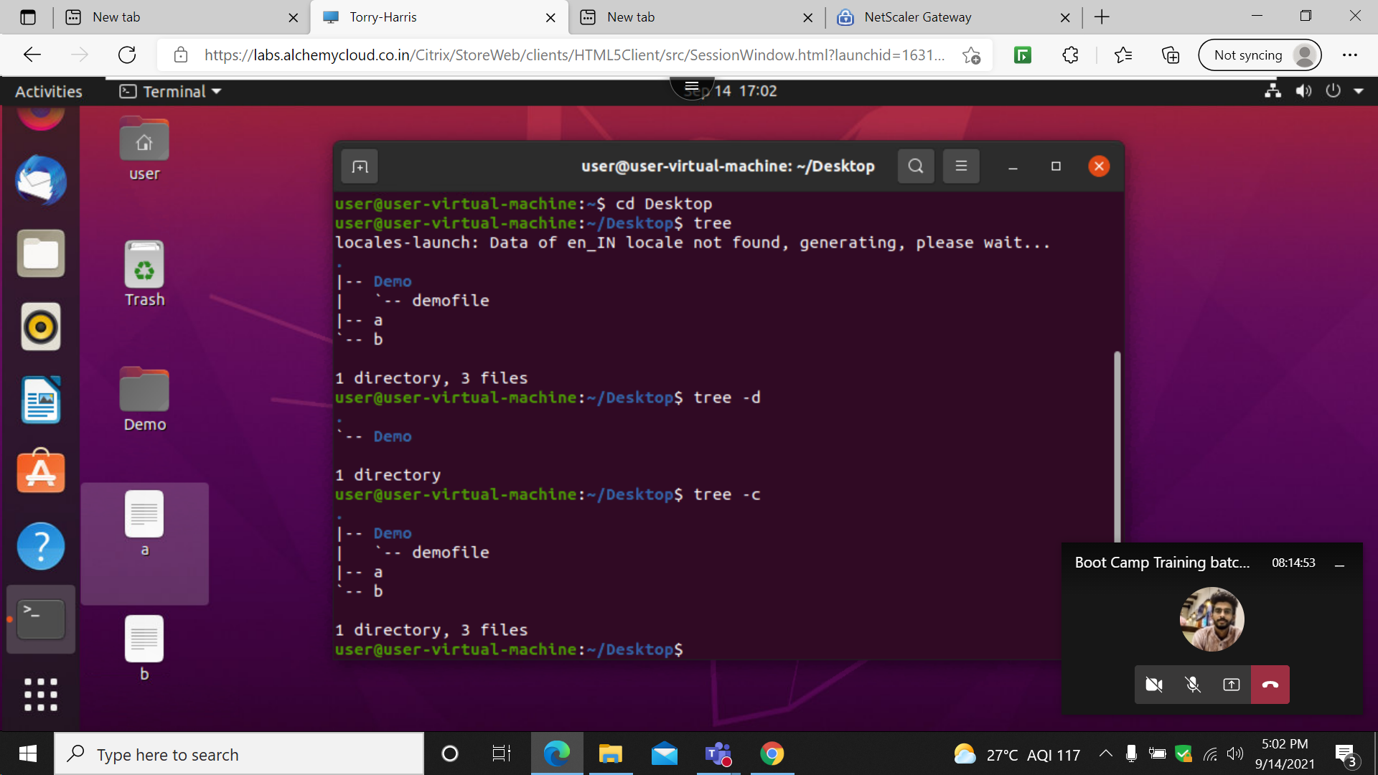

33: desktop$ tree –help

